Radar Hill Hawkwatch Site

Chaiyan Kasorndorkbua
raptor@BirdsofThailand.org

Radar Hill (เขาเรดาห์ in Thai, coordinates 10-59 '-29.69" N, 99-21'-29.59" E) is a raptor watch site for raptor migration in Prachuap Khiri Khan province, southernmost central Thailand. Since the discovery of Radar Hill in 2005, Thai Raptor Group (TRG) has annually organized the autumn weekend’s hawkwatch events from mid-September to early-November. In 2008, a season-long count was performed by Mr. Chatuphon Sawasdee and Dr. Chaiyan Kasorndorkbua (Table 1).

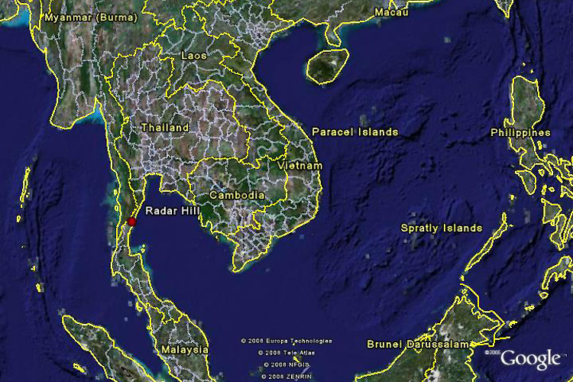
Fig 1. Radar Hill (red circle), Prachuap Khiri Khan. tupho

Twenty-three species of migratory raptors and six species of resident raptors have been recorded at the hill during autumn migration for a period of 5 years from the year of 2005 to 2009. The major migrant species are Black Baza (Fig 4, 5; video clip of moving kettles adjacent to the hill at http://www.youtube.com/watch?v=An5sKHvBhpc), Grey-faced Buzzard, Chinese Goshawk, Oriental Honey Buzzard, Japanese Sparrowhawk and Shikra.

Based on the autumn counts from 2005 to 2009, it was found that some populations of species formerly regarded as resident in the country may be migratory and have been recorded as regular migrants at the site such as Jerdon’s Baza (Fig 6), Crested Serpent Eagle, and Shikra. Rarities including Short-toed Snake Eagle, Booted Eagle (both pale and dark morphs), Eurasian Sparrowhawk, and Amur Falcon are annually observed in a small number. The site offers ample opportunities for the study of in-flight identification in terms of species, sex-related and age-class plumages due to the diversity of species; for example the accipiters (one of the most ID challenging groups of Southeast Asian raptors, especially juvenile plumages), four species of migrants (Chinese Goshawk, Besra, Shikra, Japanese & Eurasian Sparrowhawk) and 1 residents (Crested Goshawk). The site is also good for raptor photography since raptors passing the hill different directions; overhead, eye-level (Fig. 5) and bird-eye view (Fig. 11), when raptors passing below the hill top. Many raptors approach the hill head-on, and can be viewed from afar. October is generally the best time to visit Radar Hill, offering a variety of species and number.
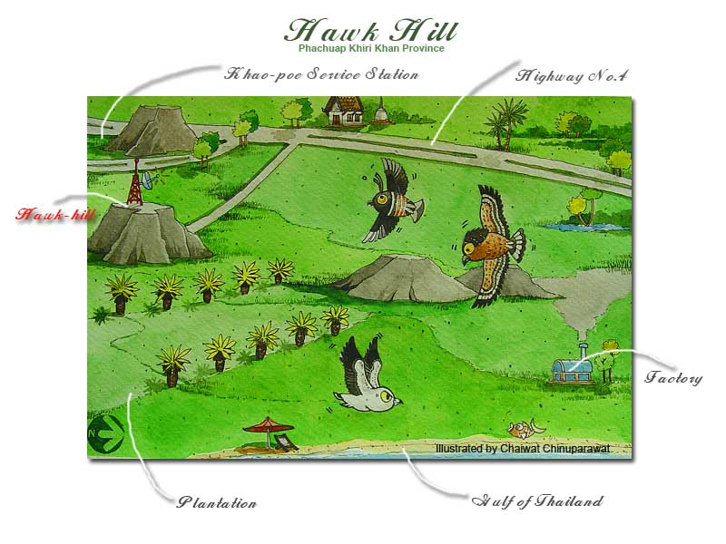
Figure 2. Map of Radar Hill (Hawk Hill) by Chaiwat Chinuparawat

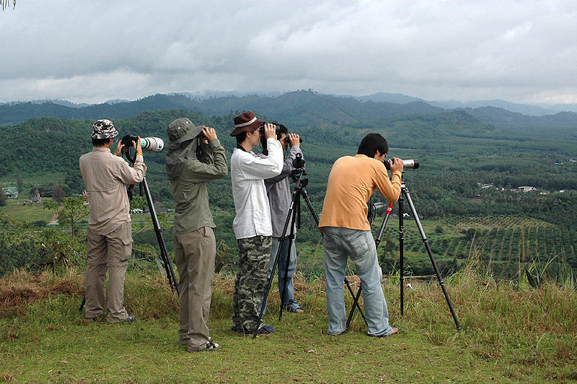
Figure 3. At the hill top, birders watching head-on raptors approaching from the east.

Table 1. Summary of 2008 Autumn Counts.

Species | Number  (% of total) | Observation | Number on  Peak Date
Western Osprey | 20 (<1%) | 6 Oct – 8 Nov | 5 (23 Oct)
Jerdon’s Baza | 23 (<1%) | 22 Oct – 4 Nov | 9 (1 Nov)
Black Baza | 81,315 (62.97%) | 15 Oct – 9 Nov | 26,730 (27 Oct)
Oriental Honey Buzzard | 8,049 (6.23%) | 27 Sept – 9 Nov | 1,814 (28 Sept)
Black-eared Kite | 68 (<1%) | 27 Sept – 9 Nov | 11 (17 Oct)
Short-toed Snake Eagle | 1 (<1%) | 23 Oct | -
Crested Serpent Eagle | 157 (<1%) | 13 Oct – 5 Nov | 28 (1 Nov)
Eastern Marsh Harrier | 20 (<1%) | 28 Sept – 31 Oct | 7 (11 Oct)
Pied Harrier | 12 (<1%) | 6 Oct – 4 Nov | -
Chinese Goshawk | 10,130 (7.85%) | 27 Sept – 5 Nov | 3,089 (27 Sept)
Japanese Sparrowhawk | 1,655 (1.28%) | 27 Sept – 9 Nov | 137 (12 Oct)
Shikra | 1,199 (<1%) | 27 Sept – 9 Nov | 104 (2 Nov)
Eurasian Sparrowhawk | 2 (<1%) | 1 Nov – 2 Nov | -
Grey-faced Buzzard | 24,436 (18.92%) | 9 Oct – 9 Nov | 8,138 (21 Oct)
Eastern Buzzard  Steppe Buzzard | 6 (<1%)  6 (<1%) | 16 Oct – 27 Oct  7 Oct – 9 Nov | 2 (16 Oct)  -
Greater Spotted Eagle | 6 (<1%) | 21 Oct – 9 Nov | -
Booted Eagle | 10 (<1%) | 14 Oct – 2 Nov | 3 (18 Oct)
Common Kestrel | 5 (<1%) | 12 Oct – 5 Nov | -
Eurasian Hobby | 5 (<1%) | 20 Oct – 29 Oct | -
Peregrine Falcon | 7 (<1%) | 6 Oct – 1 Nov | 2 (8 Oct)
Unidentified Harriers | 12 (<1%)
Unidentified Accipiter | 1,388 (1.07%)
Unidentified Buteo | 1 (<1%)
Unidentified Aquila | 2 (<1%)
Unidentified Falcons | 7 (<1%)
Unidentified Raptors | 581 (<1%)
Total | 129,123

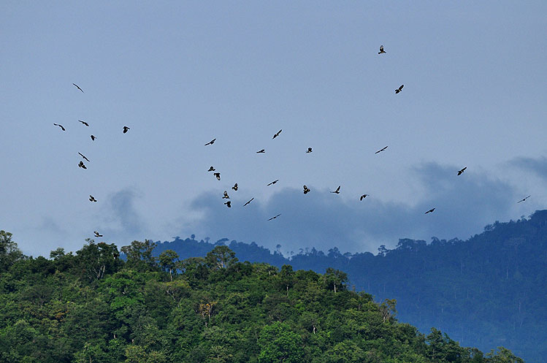
Figure 4. Kettle of Black Bazas. 2009 October 26.

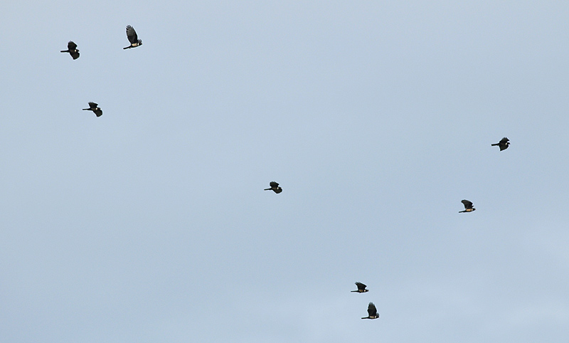
Figure 5. Eye-level view of Black Bazas. 2008 October.

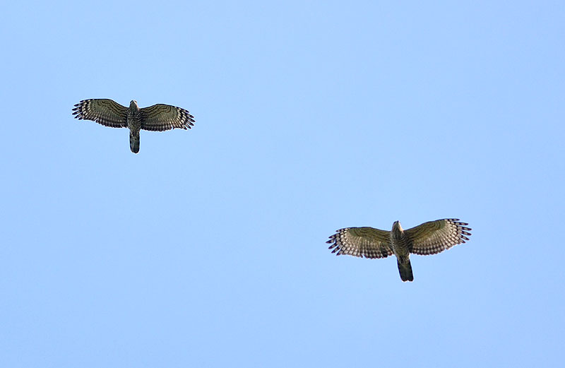
Figure 6. Jerdon’s Baza, two of four birds in a migrating flock. 2009 October 26.

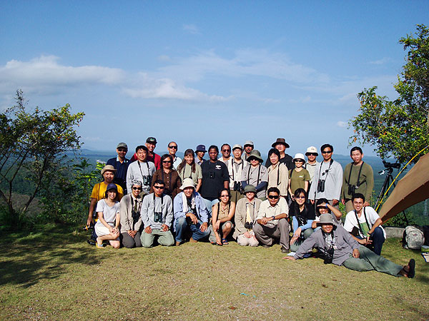
Figure 7. A raft of raptorphiles!
Direction to Radar Hill:
Radar Hill is a hill used by Thailand Authority of Telecommunication and Royal Thai Army. Two transmission towers are erected at the top of the hill at where is located in Ban (meaning a village) Chairat (บ้านไชยราช), Bang Saphannoi district, Prachuuap Khiri Khan Province. It is approximately 450 km from Bangkok and c. 70 km to Chumphon. The hill is opposite to Khao Pho service area (ศูนย์บริการทางหลวงเขาโพธิ์) on the Highway #4 (HW4; Phetkasem Road). Driving towards Chumphon and at km. post 431 + 800 m., turn left onto a small pavement road to the top of the hill. Visitors are kindly asked to park their vehicle on the road shoulder or a parking lot in front of a wooden house on the left side then walk up to the hill top (less than a distance of 100 m) in order to avoiding disturbance to the raptor watch activity due to limited parking space at the top. There is a gate at the foothill which is rarely locked. Visitors are also asked to keep the place clean by trash-in and trash-out.

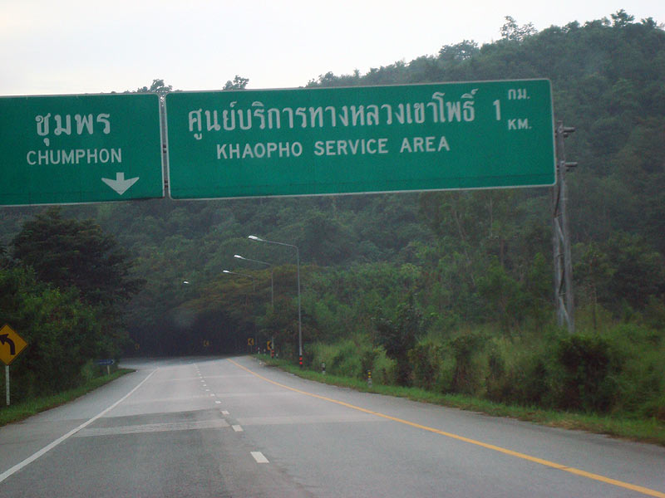
Figure 8. HW4 sign of Khao Pho service area. The left turn-off onto Radar Hill is just after this sign. Khao Pho is behind the sign on the right.

Food:
- Khao Pho service area (ศูนย์บริการทางหลวงเขาโพธิ์) offers multiple food stalls seven days a week from 8am-9pm. The service area also has a convenient store, Seven-Eleven.
- Noi’s Radar Hill Raptor Info Center. Mr. Praphin Buathong aka Noi (ช่างน้อย in Thai) is the caretaker of the transmission tower station and an excellent hawk spotter! He has helped Thai Raptor Group counting raptors since the discovery of the hill in 2005, and has been very helpful in all aspects to the visitors, domestic and foreign alike. Noi’s house also serves as a home-made restaurant (Fig. 9) offering southern Thai-styled food, freshly made daily, and his wife can modify the flavors of such a diversity of foods if asked to suit different tastes. Lunch delivery can be arranged to the hilltop as well. The center also provides high-speed internet and fax service. Contact phone: 086-1651352 (mobile).

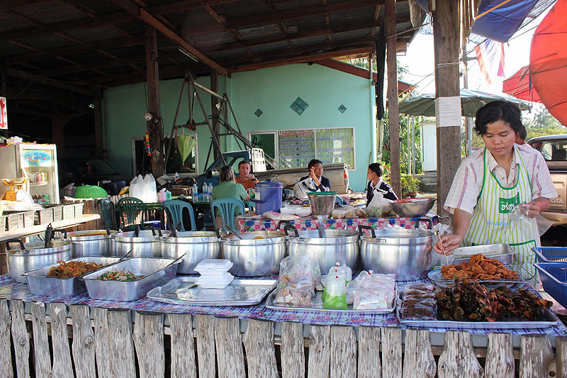
Figure 9. Mr.Noi’s Kitchen. Photo by Wannida H. Phiencharoen.

Accommodations:
- Wangkasem Hotel (โรงแรมวังเกษม). This is the closest basic hotel to Radar Hill and is within a walking distance (of 4.5 km) to the hilltop. It provides both fan and air-conditioned rooms at a range of THB 250-500 per night. Laundry service is available. The hotel is c. 2 km south of Khao Pho service area. To get there, drive pass the service area and at the second U-turn, make a right turn back north and drive onto a small frontage road which runs parallel to the Highway #4 and the hotel will be on left-handed side with a big white sign (see following fig.). The hotel (Fig. 10) is also close (20 m) to Mr. Noi’s Radar Hill Raptor Info Center. Contact phone: 032-694574 (home), 089-8667731 (mobile).

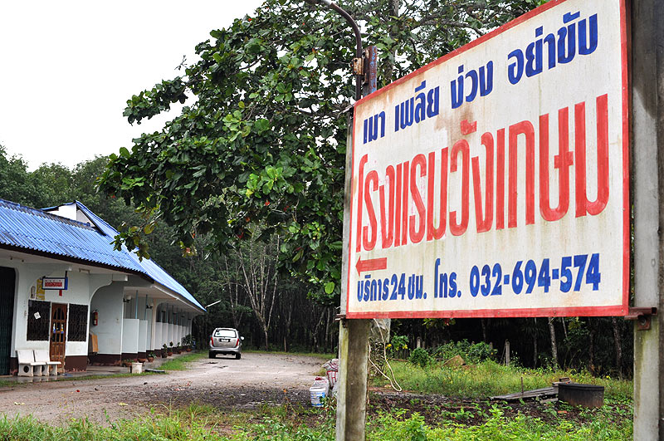
Figure 10. Wangkasem Hotel.
- Sudsabai Hotel (โรงแรมสุดสบาย). This hotel is located c. 1 km. further south of Wangkasem Hotel on the same side of the Highway #4. The room rate is ranged from THB 300-500. Phone contact: 087-7529149 (mobile).
- Big At Palm Hill (บิ๊กแอ๊ด ปาล์มฮิลล์). This place has 4 resort-styled air-conditioned wooden houses near a foothill in Bang Saphannoi district. The district turn-off is located on the left side of the HW4 if driving towards south and c. 10 km from Radar Hill. The rate is THB 400-500 per night. To get there, from HW4 and 10 km before Khao Pho service area, turn left onto the frontage road at Bang Saphannoi sign (note the elephant statue at the turn) then drive eastward for c. 4 km, the resort is on right side. Contact phone is 081-7728104.
- Resorts in Bang Berd area. There are a number of resorts at this coastal tourist community. Bang Berd is c. 25 km from the hill. Its turn-off on HW4 is next to Bang Saphannoi district turn-off.

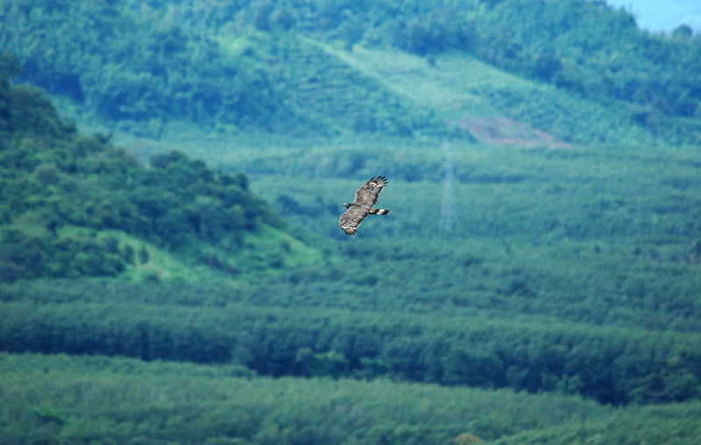
Figure 11. Bird-eye view of a male Oriental Honey Buzzard.
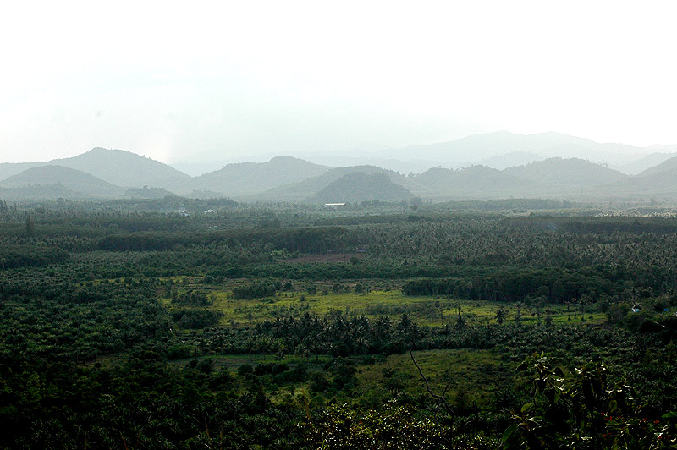
Figure 12. West view from Radar Hill with Tenasserim Mountain Range bordering Myanmar.

